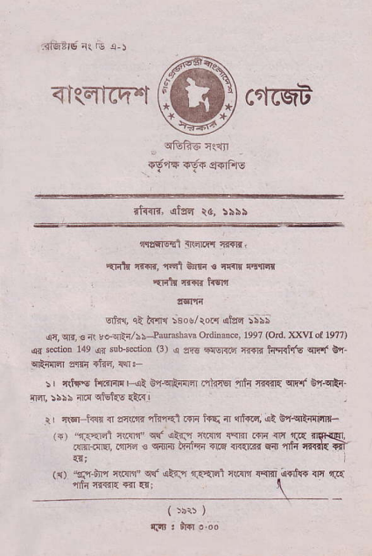
<lqr6q-"t ^{c{cqa} ffi
airRrl. ^{€fufi} ta,5\sa
{rzfiqd 3Rarifl Tf{n,
qlrlF 'r{{r., nql 6itr{ ! cd{ri elrn
{rqtr i-fi,n frEIn
_{sffl,} ^{qt} t{'rq 5so!/rom attq ibsS
.94 crr, € ai _{!.-qE:/!!--Pllmha$} OrdinDcc leeT (otd xx\4 d 19?7) qr i..lio! 14e !j{ rub{@tid ⁽³⁾ a _{a'.€ F{slri.d r€rI hq{irf6} ^{qr'f} Cq grift]'n aqii *Ff,d, {q.
_{:r} qrhE lr&?r{I{ t<i €,r-qii$cr i,dirEr _{:nh} nT€I{ Eft]r B'r-q!l- {r{ 5s\5 rlF ctskE.tc{!
U clal i@ { ^{ar(ill{} _{"liir<l} .ffi t4S { qrtud..qt g.r,c':flm{- , . , ".[FF" _{{r.r TIr" ilfl^} ^{prql !s} .@ @ _{]r{} rrFq
^{'tl."} drn _{{.r1} ^{q} llrn ^{rta.'ljlM lsEr_ldft+} _{fc} rJE
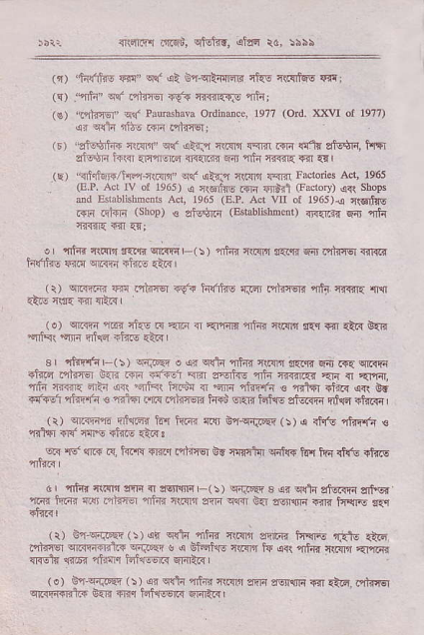
ir'4xF fir.6i, _{f,f-frd,} ^{qilc} rc, lbhb
_{(,r)} ^{'tq{ini} _{m"} ^{q( qi} En!014!rdF ckt {lt:rf4s csr: ^{(q)} _{"rdi" *f nii1lEi +f$ ft{:r{rF} ,fih,
_{(c)} ^{'dlT@" qlr} _{Plunshrv. ordin.i.!, 1977} (od )o.r, oI 1e77) _{ci} ^{qdn} !t! FFrn .niirer;
^{(F)} "aiE$ri-d _{*rfl} ^{qlr} _{<la!n} qtm ^{zlm} Fr {! h Etu*r, t4rr
_{(E)} ^{'.ftitiF/tM} _{{1.l1n"} q{ ^{qti,r} _{crRrn li{m} lrcbies Act, 1965 ^{(E.P.} Ad lv ol l96s) ^{q} rFrJF _{Fr srlil} (Irrdory) qr\ shop6 rd lytr6l(bncDb Ad, 1e65 (E.!. Ad vII ^{oi r96s)!} frdfirE mrr _{.rhir} ^{(sho!)} _{s} ^{gfrrir} @srab,isbn.no _{n€itr{ F} ,flir
_{o 4t{r} ^{qtmn} _{a'..r<} ^{qiir{ L-(:} ₎ ^{,.i;R} rimin o'nF ddt ilknq {rRrd _{h'frli-} :r"iii{ ^{qrRin iiic} {ii
₋ ⁽ _{r)} ^{Eniffi m dhnq} _{€{ h'i1i.6 r]3r mir5.€ir rii} ^{'rr{ir{} rr{ _{(e)} qi<rT ^{5m ckE.{} ?ri{ { ^{qrrirs} {hr ctl{]r lqq Eri:t{ ^{b{n qf5t} rrF hrl1E ^{ili|E} *!1 _{B} 'fnt'nr ^{(i} ₎ ^{qii'e} _{o} ^{q{ qft{ rl.fa:r} r(w _{s...rn wir .T{} qriiin
.rlnq ^{pilft-q} _{i{R .ir4 iq'tu1} ^{qr e'elliE rfi {..mi"{} {r;r { qF, ^{'flt{} _{n{fi 4b a{l} ^{'jiFr} _{f4ai\ r} ^{,ffi} _{nh{fr €} ^{,frtR} _{<liR} ^{q{r} Er _{nrrdr rtuli <} ^{'rtrier} rri{ i'riirn h{u sr{l;l ffiN- starrr ^{!ri{a} "tor{, _{({)} ^{qcj1nft} drr.o ^{hr ltrri mr inqniirw} _{1\)} ^{q} rtfq {firf{ s ^{,ftr1fl} sI{ cclr dflr .1"{ !
₋ Eil rd cr.{ _{rx t{'n} ^{qi.{} niicEr _{br {i{d{} ^{qiiT} 1ai h{ rt b dflE
_{d, rt{r f\M *x m..!rFnq} ⁻⁽ _{i)} ^{qiTRq} 3 _{s.} ^{qd4} !ftlrlq ?|fF. _{"r.4r} ftirr fl{j _{flitF} ^{?iri4.} _{ft.rjn :m} ^{qcRr} tar ^{soRF .ir{} tsF{r- sq! rtur I
(t) _{En} qid6rft ( !) at _{sd4} ^{qihr} r".im znirir in'G i:19 {n d _{l"diTgl} q'|lq;l.{Lr ^{q{..iE} ! ^{q} oishE crff _{tu as{} ^{'rilq{} c${{ nl'rFt _{rl{eln r96i} ^{'riiflq} H€Eti Enrli{ |
(o) Gnq{es (r) _{ar} ^{qrft} Thi nr.rn lqtr ?rff1lrr fir {i.a. .drEr ^{sKqn:F''dl{ B.r{} _{"rnq tdirE€tr{} ^{qnlri} I
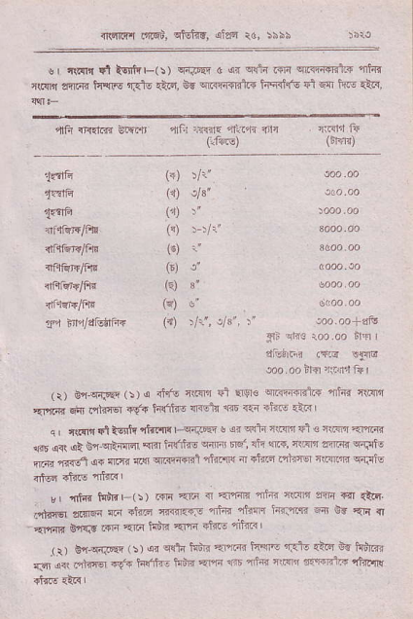
{slrq'r.iz6us, c'fot4d, ^{ola6} ro. riis
^{q} _{tri{t $1&ftF(!)} ^{qni'Rn} _{c} ^{qr} _{cfF tnr} ^{qrRi{riit+} "nhr clRlr *rdr hc1E r.dlx qt4, _{i{} ^{qrlr{fld.1} hq{i{'o ₅₁ ^{qm} tur Q.{,
⁽⁺⁾ tr'
({) rA',
(,r) :"
(") : ri'
(€) i'
('l !"
(q) 3"
(*) ,
^{(O} Vr', _{r3'.} 1 'a..ao+.a76
_{fli} :rr3 {oo.oo 6rq
diiiri iEir !li@
so . oo rh {rrfi,t fr I
(r) _{bn-{rFe} (\).r drG i(@ $l {|er€ _{wir@.n+ rh{} q{?rn _{Er.lrir} ^{q\'} .'i1.ns1 $€{ ti!'ftF <r€itr ffi r1n +fr.u <:e I ^{q,} _{c{F!qlt€ilr"timr} ^{qiia.} _{! ar} ^{qrin} _{itm} ^{ql} e rtm aflF{ _{$r} q<r dt _{ir} ^{qrt{ar} _{Rra hffr6} ^{qdrB} F{, rh <ti' {{Td _{awrr} qr.itE nrdl _{fiTla} (i :nm qai qRrffil 'rtimq ar a1iflq ifrrlr ntRn qini5
v _{frfr{. ku>Irr} (i) _{rrrn} qF { '{'cn {hr ctFf Ttli T{i {t6. .zti€ aarn.i {c{ +iTcr m€rrp rn r _{rLqf} ^{jn{rs} n bs ?i rl {".rni 6a{^t ^{rqr} _{".6 Fd]n} *{rri ftire nltftl i
_{r b-ff..F 5.} . _{s{ji Ynr aaa} ^{e{a} _{Ft'} ^{-}G} }t hria _{rsr G. trT.@ {s_. letrrii: tn!} q 5 ' _{a} ^{_-rrt} FY^ F F'a 'ttFrq
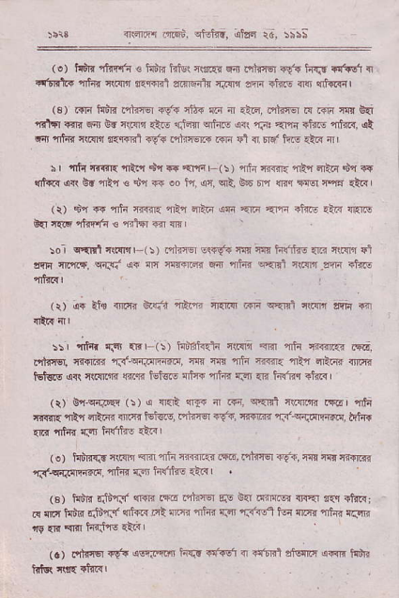
_{4r1{'4rin in;i.} ^{qtittr. qilrd} rt, iii;
^{(.)} i{ir.' dicfr € tdri nfst rlu{i ₁₄ ^{prriierig<r} hrJ #.!1 { c{mlir 4d.ir c{{n _{tl.rn<l adnqrtu fi{{ m iire m} qd€sil
⁽³⁾ mr tu":R.'rlrlEr 1f{ r${ {r rI .i<, _{rqi?fn F m n:I{} g{ ^{qri*} tri s'ii _{Br} ^{qF} :trc _{rrlEn} ^{qrhre a{t} rn arna _{{f{.e} 'akrc, ,et ^{cfl} _{"lrhr} run'r aE F!r4l rt'F ."nrEqF m Fi { n# hF {ln {
i | ^{'r,t{} _{ffir{ {tor d1} ^{qr+} €pn F( 5 ) afi m{i{ rrla aEir d'r ?q rrtr|q,arl 6r aR,l€ fi ra oo in _{ar,} ^{qrl.} EE' F r ${q _{ffi} ^{pr} {tts
(i) dn R {h rniR rtu _{dr1'd} ^{(F} ErF ?rF iliE.t< rRre &r ft.6 _{iffin !} ^{'r.h} w m
:o _{I} ^{q{mlqt.{I,rr'(i)} r'rlirEr !s-*r m iE hfjtuE..il IlR]r $i _{c{rq rE'l.4,} q{3i ^{q{} _{nc} ^{qrffi} Far rfir lEm ^{ilmr} _{-?m} alil!
(r) 4F il€ ^{<nT. Ez{.'r} _{"ni.n} fi{m _{m} ^{qEEl} cim aFn.r
^{-, itt*} _{"ro} *' (!) _{Siiielr} qtilrr ^{qFlr} {ir {i{fl..{ isir.
_{Frtnq c'{FR} 'r.r'-c;r.iqfi.:@, _{cls 4ri nrti {tr{iTr} ^{,ni1} aEiR {mr tot!|s ,ir\ lni{.i rnqr irt€1! {tu{ {inr r.a ^{qr{} _{h'ri?q} ^{qliir} r
_{(t)} g{-q{.en (!) ^{q} _{a.E} ^{q{r} a .ra, c..Fl 5'mF{ rrirr 4'la aril{ afu Ffoi rlnr{ H<.E, ntinq +!.r, i<.r'F {3-q;!ilTr{tr. fdrF _{{ra} 'nt4d rFr h(litr5 _{Q:e} I
(o) hiffF crc{rl @ _{"fF} Tiiilt.n .'f6, .'friEr €6, als cq|t'rioclr _{{S'.cfr'-rtr'} -fe ftn'?r5. -'r{r '
(€) 6R _{tritT,"r} ^{qlr]i} m ?rtirq qE V{r in4mtil {]€r lln dnri .q mq tudln d$r..r _{{d€{ .ri} ^{'"lFr ,'li{i} {.a {F1tul ic{ n r'{ Tk{ qm
(a) rilr{$ _{aV{} ^{qf..!m} hr$ rfF6 { <iffi atsrr arqr< fts kk ft{.ta(< |
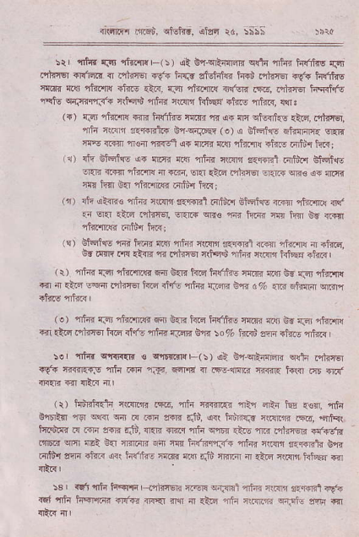
rll-Brr inci. cffi{t, &t!.r
_{rrr T'tir r|r} ^{.itn.lll{r-(:)} _{!i: brqtallrR} ^{q{ta} {frr titrfiE r{lt .,nI,|El {lf6.n {r En rq rpe{ krF atutdl!1 iwi .drrEr 19.r tufituq trFd _{rtqr} ^{,'krfl{} ri?69 {4.<, fr$ frrinq 1't'6r{ 6d, .qirqEr tFd.f6 _{n'ctu} ^{q{r+r'{ir'F} _{nf,q$} ^{.ni4r} 'l _{lljr ftlaa} ^{qlfls} atuF, ctr'
(r) _{Tnr} ^{'{tir|lr{} lRri t{filns fiR R ,erF nn $o{n{c {tF, !1dTjlsr, th cwr a*r+nt+ Bts{.w (o) ^{q} bffi.F sh{ilc,r sER _{rNE} ^{q.crT} _{ftar} 'l'ls.l L4r {l.r{ ftir d40rr{ drF 6fi{ ft.q;
^{({)} dv Eisl€,4r curi r.{r Tfqd ^{'r{1l!l} ff{Et !qt"r.'r bkinl. sErd _{r.Ffl n]3.w} ^{qr} {rr{, eE| cld _{crircEr $15r$} ^{qR€ q{} lllr|n 'I! _{im1} ^{g'{} ftr'inr r{lfi.t ft {r
(r) _{dr at{r{€} ^{ent€} clFl'f !r!*El fifdr{ bhqt{€.F{r ^{,iftr'nd} <ltf _{5{} q{I ^{ql6} _{ntrnEr, 6r{.'{} ^{qrd! qTr} irnr nm kr br rqr rirrrEq litur{ fn{r
^{(si} dtqfiq ri _{h" ear} ^{qf?{} ntr{E aqr$ril riFn ntum ir fnc, 0r d{R a.|{ _{{t{R} ^{'fr} irhnq {$c$ a&? rl.{{ hkF rhr{ | ⁽ _{r)} ^{'rfi{r} _{fF} ^{qt'r{li{{} 6q &r{ h6 h'fihB {IlT{ l!'r td fJI ctoql{ rn ir dr{ sqir.|t{|El ^{fqiE rfi'b} _{"rdqi} 5-3m 6'rd a% ^{{r.{} _{"fnnr} lin{jn
(!) rik{ Tdr ^{'rfrmdn} _{6r} ^{q{F} fr.lr h'ff{E rr.n{ &s bn iFj rturli{ .n {lGr tqhtq lr.E +fq {in rFR b.& |o % irRus afl{ {t ^{s} _{"farr} j _{:.r} ^{'ntir qrrrF(r} e *iwftF(r) {t V'r-cfinrBn ^{qd4} rjhn€r _{}({ Ir{{ErF} ^{rrft} _{.{li} ^{..F..} Fi\i rl i!€,cEra ^{3.i{i'E} tq{l dr TlDf
^{(t)} t{firt{{ti f.irin.rE, dr _{4rri@r} ^{'nt{} ae{ kE {€4 Tfr _{orFRir rsr} q!ff ^{q{} r! ern $rr{ r&, a<( fttR_a calnr{ _{dfE,} 'Efqr. tr!.$rqr r{ r{F d{T' _{r&,} ^{q{n} ?Erc di c.rir its nt{ Fnr-j€I' .r,{Ett _{.TEa} ^{qcl} {'It G{ rriEiR ddr |!n hdnl3t{ Tfid rti{n _{fi.ffrtj} g!? .{i?i{ liln {t{ir a( ti!'fis e.n flir r.S flrlirr ir {t !r ct.Tr hk lRr :rd& |
_{$, rri} ^{rnfr} hq|ti F?il?nEt. _{nr51{} ^{q{3nt} nkr f\FFr a{f Rt <6 "*F
_{"tr} hqr"l|{{ {lt'{{ rREr rrr m +&.r {ii _{w{.in} ^{q{rt6} _{cqli} qr
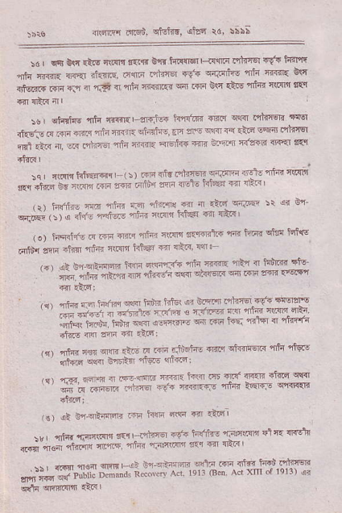
_{{rtflr ir.6u>, trtd{',} dlzq 16, :i\;
5d _{I} ^{q$} t\c {i.G rl.cE t{i'n _{bfl tffi6r} I ir1lrr i"rl_{fq +!" ti]Il'r{ {ih r*m. rR'qI if<rtE. l1q'I niirq _{r(F} ^{q{.Fdie} {h _{rni:} g16 _{riisal{.Tl{} ra { ^{'r.?i} n _{ain Tir?rG"} ^{q4t} _{.{i bj{.\i6} 4t{4 RFn tT' a{tR{l
_{iur} qtirtuE ^{'oli} rfl.r. 3rd!- hdR _{r';!.'(} ^{qsq} 'fi:r€Tr a!81 iftEis i{ FE {{q rfq _{r.{iR} ^{qtqltrd} _{:r{ ?r:€} ^{.K} +{ _{{i'd} tffi nhn6l ml a'n ir, _{c{."rii@} ^{'nJr} ainr. <Frt4{ <:r o.ff Tnffi {r'a d{l .l'.d i
_{a ' 'ffi hliffir} ' : r _{ri} .f! ^{.-!?4} _{"riF} r+ {f4 4"!q _{&r {t{} ^{.-'FF1rn} _{F} ^{(rrF} ₃₄ r'-l''dm @ -ir? _{,e, knh, 'n"} ^{.fi} r.a cr _{c.{} 6 t}4 r{r7 :' ' !" ^{q+rsr} r . r _{o} ^{qlt} *fr rfq 4F! hl6 41 {'c
^{(o)} _{hErfri.} .i _{m} ^{.im} 4t4r _{nlr'l il?rndii"} ^{'lri} _{titi'} ^{qLE} leftE _{diir a@} il€ Tft flam ki@i R flar< r4:
_{,- . .> i..ffi hfi} q ^{nn-:ra} _{"-'n l@} ^{-+r} d bi@ 6(e
-
_{-o} -'-",r--*"--,-@ {2ftF@.@'EF
_{n} qnnnmFm ^{5@5nF+} " }!- ^{n'E-ot"} ""i*=sE _{|m &. {'rtn'-} ^{F'@} _{" "SlF rs} r:'Mffi
_{.Li l-*"} tr" @ _{r} ^{'d} _{fl!} F .n _{rtrt} ^{'F"F '} "e"'fn _{af-e aM} ffi {fl rLai
_{n '} 'di. 'dr tc t_, n ^{.-} _{"n+ -<' qt'iJ-@ ''J'} 'lq
{trc _{o@ 6@-a} 'nn qqrtr
. ^{-.f} s _{_:f} al@ 6irF ^{drrd} -*"r_
_{r€)} ^{qi} _{BnqinrdF} .:ri h@ Rq n 'ir{l
^{-6.} _{t-/rh} Ft _{F"} slu dN\
*; *." _{"i"* -.' dn4 ljrdq'c} q q'r'
_{"s'S-Ji;} ii:. n .;-a r.
q:l'-r.fi.Gfte9;r
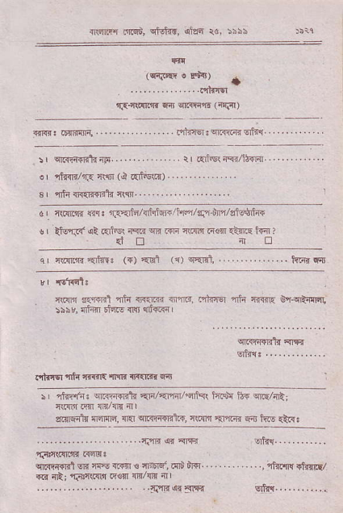
rra]r'l mrq6, El_rtrd, oile ra, :\i\
^{'q;c@ o rii{ r}ID
^{qs{t} _{rFrr F{r} q.nir (q{F)
:' oFfirnt _{rF} ........ ... . !, _{r'fs} ^{iqi} _{$!rdr} .. ... _{or} ^{'l1irli/d3} _{ft1i} ^{(d} af'${d)
3 | _{dn rJE1Tf.rFt {{1!r..} ..
d | _{{.sr|'s aq.} ^{'E} €kArhtur+./hq/lqf&r'rlafutfft
,. _{lfuf!#} !? @i's. _{iEr. F.r"} ^{:l,@ F@} _{"lfi} ir{ d! rI tr
^{q} _{ffir1{'{i'tr{!} ^{(T)} _{<ril} ^{({)} _{s<il,,} . . . h.T{ €.{
*rwr _{r.fnfi th} ^{qr{ri;l} ffir.il, trdicq Trh TiF{rF o'rqtflrql :\hv, fllr:.n Eifto _{iRI} {rf{..4 L
_{rlir"rq} ^{'nt{} _{nfi.€} ^{'Itfi} T'€rR. 6
: I _{riir({:} ^{q.fi4{rCF} {Fll'qrFdqricr tsi${ lt{ sr.E/nRl mrdilr _{ir4mE,} ^{qr{(} wrfi+Bfto, i-\i{n ^{qr'{rqr} 6dr h.s dt{. ..........-............'.iI{q.5'rr oftr.........
^{qr.{i:{{nl} _{sR} ^{qis} _{ridn € nrn{, dru'fi{l} - ^{. ...,rkr{sl} [E/ *{ {&; ^{'f\n:r@lt} ijis{I rt/fi rI L
_{..tIR} ^{qr} {rF
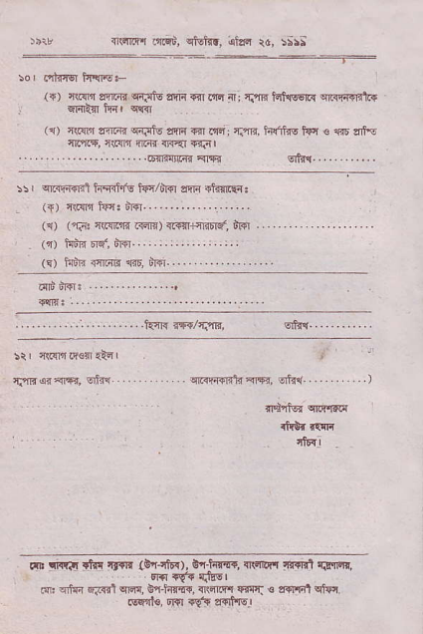
n'n'iF ^{,'riit,} rlEifi, {l!a rc, rs:;
iE) 4(.1ln as'r{{ ci3tu rfiri ffi oFr {' fln ht{qqi{ srirrqqnt{ s]qli$ hnr c{{r
⁽¹⁾ _{nlrn enT{} ^{qdlrtu} lnr *l nqr f.'rl{. h!'tus tun € 1s zfll5 cn'tF, c{cllr sr.{r {F{l Tqn I
'.........,..,....,....,6{riarFrqfi sfifl..,.........
_{5sL} ^{qrqi.ftni} hqdfe kvirfl !a4 iftftliI
(1) r(.slr tur. fi$r....................
\{/ (?i: fl.lr .@) 4i64{FDF, h{]
(t) hnr nd, iR r''. . ... . : :
(s) _{l{u'ri rnarr $r, d{..-.} .............
_{ad,'pr:} . . ...'
............1.....,.i€ni@/iAr., qi'{..-.........
:ir crrff.rs{ atE I
fin*orm, od:{1 cr.{rrFrilr ar6., 6rld,,r' )
_{m} ^{qrr.I} _{ihI rynl{ G{qfF),} o+hr{q, rR'r4" nFBt {Iql'1r, EI+l +q! l;]lct
_{N:} ^{qhn} !is.]qr.a, E"r hie, <ncrittr rr{c!l: € tr!n1qtur 6rqil€, ^{orsr} E? ?|frtqql

